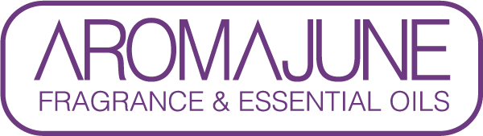

DATE : {{DATE}}
TO : {{CUSTOMER}}
SUBJCET : Methyl-N-Methylanthranilate CERTIFICATE
PRODUCT NAME : {{PRODUCT}}

AROMAJUNE, confirm that the product mentioned above does not contain Methyl-N-methylanthranilate(MNMA, CAS No. 85-91-6).



